***Cambridge Hospital***

|  |  |  |
| --- | --- | --- |
| **Batch.** | 2407G2 | |
| **Group.** | A | |
| **Serial No.** | **Enrollment Number** | **Student Name** |
| 1. | Student1594552 | DUA SHAHID |
| 2. | Student1586656 | KIRAN AKBAR |
| 3. | Student1594544 | SYEDA KASHMALA QASIM |
| 4. | Student1594540 | SHUMA REHMAN |
| 5. | Student1597223 | KAHSHAH |
| 6. | Student1597226 | SYEDA ABEER HASAN |

|  |  |
| --- | --- |
|  |  |
|  |  |
|  |  |
|  |  |
|  |  |
|  |  |

***User Guide***

***1.Welcome (0.Welcome.html)***

***Figure 1: Welcome Page To Cambridge Hospital.***

***2.Layout Top***



* Home Page (1.Index.html)
* About Us Page (2. About Us.html)
* Contact Us Page (3. Contact Us.html)
* Service (4. Service.html)
* Pricing(5.Pricing.html)
* Department(6.department.html)
* Department-detail(7.department-details.html)

***3.Layout Bottom.***

***Footer***

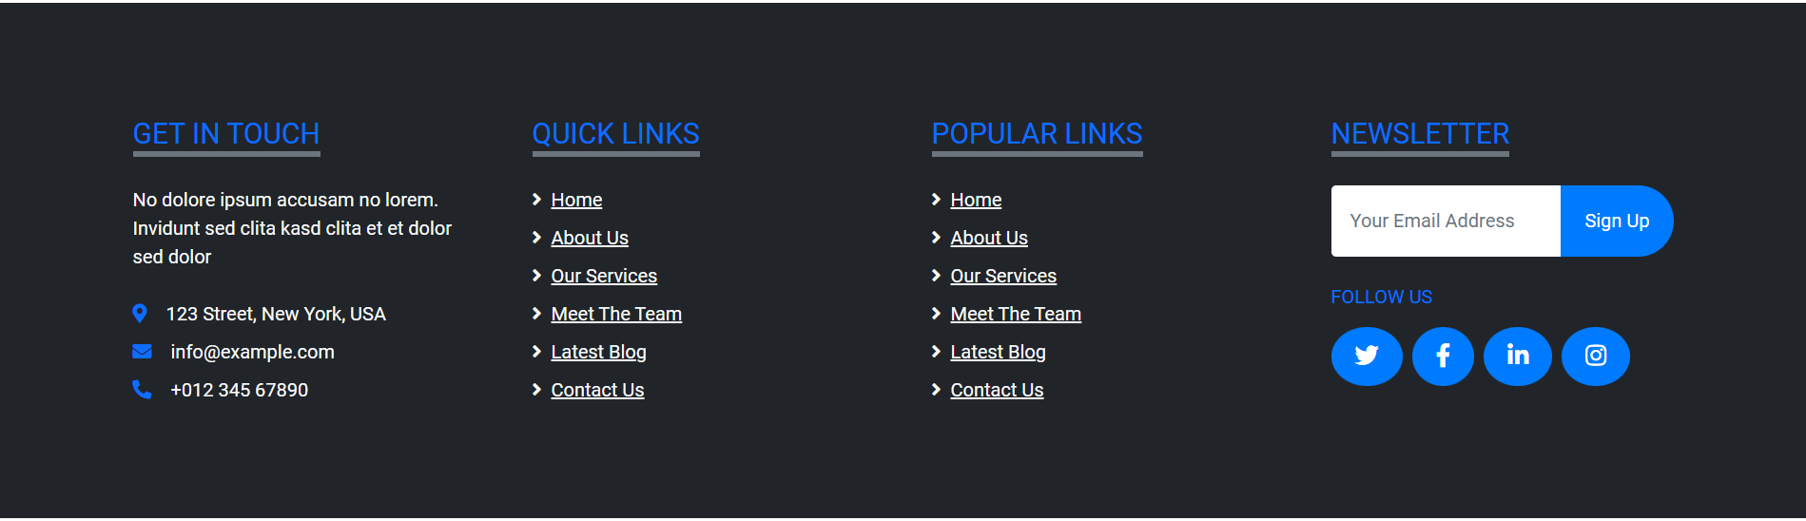

***Figure 5 : Layout Bottom.***

**4.About us page (aboutus.html)**

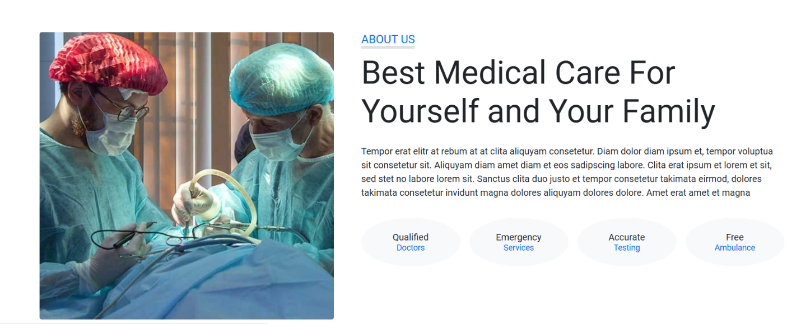

**5.Service page (service.html)**

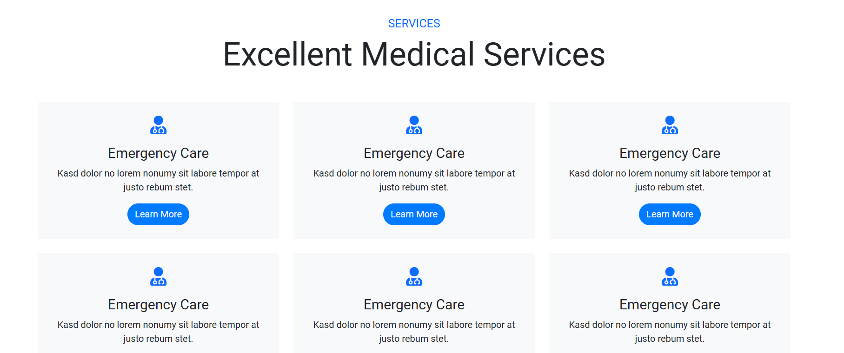

**6.Pricing page (pricing.html)**



Service page (service.html)

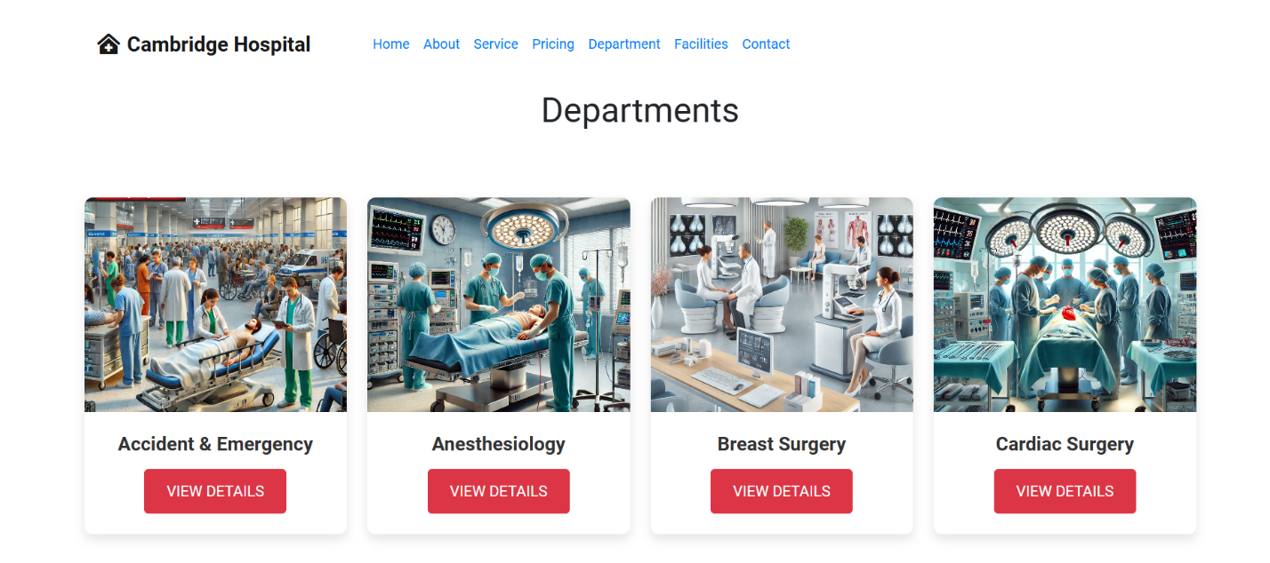 ***Department page(department.html)***

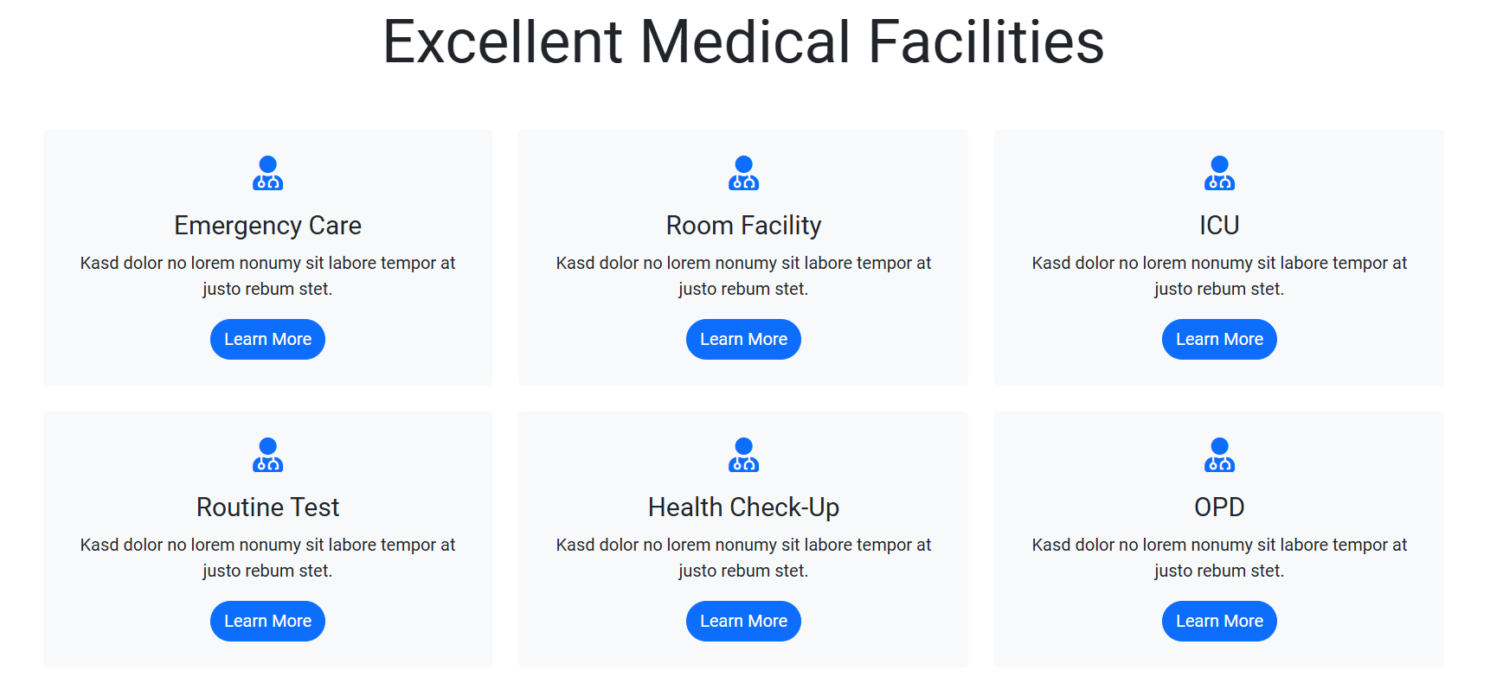***Facilities page( facilities.html)***

